# The *las* and *rhl* Quorum Sensing Systems in *Pseudomonas aeruginosa* Form a Multi-Signal Reciprocal Network Which Can Tune Reactivity to Variations in Physical and Social Environments

## Supporting Information

### Literature Search

The PubMed database of the US National Institutes of Health was queried on 20 July 2021 using the query [PubMed Search ("review"[Title/Abstract] OR "review"[Publication Type]) AND "quorum sensing"[Title] AND "pseudomonas aeruginosa"[Title/Abstract]](https://pubmed.ncbi.nlm.nih.gov/?term=%28%22review%22%5BTitle%2FAbstract%5D+OR+%22review%22%5BPublication+Type%5D%29+AND+%22quorum+sensing%22%5BTitle%5D+AND+%22pseudomonas+aeruginosa%22%5BTitle%2FAbstract%5D&sort=), resulting in 76 results with publication dates from 1996 to 2021. Papers that incluced a daigram of the gene transcription networks for the *las* and *rhl* quorum sensing systems were further analyzed to show the interactions present on those diagrams. Tables S.1 and S.2 show the results. Of the papers analyzed, all show the *las* system positively activating the *rhl* system, and none show the *rhl* system postively activating the *las* system.

| Paper | PMID | →*lasI* | →*lasR* | →*rhlI* | →*rhlR* | →elastase |
| --- | --- | --- | --- | --- | --- | --- |
| (García-Reyes, Soberón-Chávez, and Cocotl-Yanez 2020) | [31794380](https://pubmed.ncbi.nlm.nih.gov/31794380/) | ● | ○ | ● | ● | ● |
| (Rutherford and Bassler 2012) | [23125205](https://pubmed.ncbi.nlm.nih.gov/23125205/) | ● | ○ | ● | ● |  |
| (Proctor, McCarron, and Ternan 2020) | [31971503](https://pubmed.ncbi.nlm.nih.gov/31971503/) | ● | ○ | ○ | ● |  |
| (Jakobsen et al. 2013) | [23841636](https://pubmed.ncbi.nlm.nih.gov/23841636/) | ● | ○ | ● | ● |  |
| (Soukarieh et al. 2018) | [29999316](https://pubmed.ncbi.nlm.nih.gov/29999316/) | ● | ● | ● | ● |  |
| (Tateda 2005) | [15926474](https://pubmed.ncbi.nlm.nih.gov/15926474/) | ● | ○ | ● | ○ | ● |
| (Williams et al. 2007) | [19249239](https://pubmed.ncbi.nlm.nih.gov/19249239/) | ○ | ○ | ● | ● |  |
| (Heurlier, Dénervaud, and Haas 2006) | [16503417](https://pubmed.ncbi.nlm.nih.gov/16503417/) | ● | ○ | ● | ○ |  |
| (Le Berre et al. 2006) | [16631332](https://pubmed.ncbi.nlm.nih.gov/16631332/) | ○ | ○ | ● | ● |  |
| (Juhas, Eberl, and Tümmler 2005) | [15816912](https://pubmed.ncbi.nlm.nih.gov/15816912/) | ● | ● | ● | ● | ● |
| (Donabedian 2003) | [12799145](https://pubmed.ncbi.nlm.nih.gov/12799145/) | ● | ○ | ● | ● | ● |
| (Reuter, Steinbach, and Helms 2016) | [26819549](https://pubmed.ncbi.nlm.nih.gov/26819549/) | ● | ○ | ○ | ● | ● |
| (Yong and Zhong 2013) | [22767136](https://pubmed.ncbi.nlm.nih.gov/22767136/) | ● | ○ | ● | ● | ● |
| (Welsh and Blackwell 2016) | [27268906](https://pubmed.ncbi.nlm.nih.gov/27268906/) |  |  | ● | ● | ● |
| (De Sordi and Mühlschlegel 2009) | [19845041](https://pubmed.ncbi.nlm.nih.gov/19845041/) | ● | ○ | ● | ○ |  |
| (Winzer and Williams 2001) | [11437336](https://pubmed.ncbi.nlm.nih.gov/11437336/) | ● | ○ | ○ | ● | ● |
| (Schuster et al. 2013) | [23682605](https://pubmed.ncbi.nlm.nih.gov/23682605/) | ● | ○ | ● | ● |  |
| (Papaioannou, Utari, and Quax 2013) | [24065108](https://pubmed.ncbi.nlm.nih.gov/24065108/) | ● | ● | ○ | ● | ● |
| (Roy, Adams, and Bentley 2011) | [22112397](https://pubmed.ncbi.nlm.nih.gov/22112397/) | ● | ○ | ● | ● |  |

**Table S.1.** Activation of QS genes by LasR/3‑oxo‑C12‑HSL in review of published literature. Solid dots indicate positive activation in the paper’s diagram of gene transcription, while hollow dots indicate that the diagram shows no effect. No diagrams indicated repression. Note that some papers made no attempt to indicate particular interactions; several, for example, concentrated strictly on the QS genes themselves and did not show the effect on downstream genes such as those for elastase.

| Paper | PMID | →*lasI* | →*lasR* | →*rhlI* | →*rhlR* | →elastase |
| --- | --- | --- | --- | --- | --- | --- |
| (García-Reyes, Soberón-Chávez, and Cocotl-Yanez 2020) | [31794380](https://pubmed.ncbi.nlm.nih.gov/31794380/) | ○ | ○ | ○ | ○ | ● |
| (Rutherford and Bassler 2012) | [23125205](https://pubmed.ncbi.nlm.nih.gov/23125205/) | ○ | ○ | ● | ○ |  |
| (Proctor, McCarron, and Ternan 2020) | [31971503](https://pubmed.ncbi.nlm.nih.gov/31971503/) | ○ | ○ | ● | ○ |  |
| (Jakobsen et al. 2013) | [23841636](https://pubmed.ncbi.nlm.nih.gov/23841636/) | ○ | ○ | ● | ○ |  |
| (Soukarieh et al. 2018) | [29999316](https://pubmed.ncbi.nlm.nih.gov/29999316/) | ○ | ○ | ○ | ○ |  |
| (Tateda 2005) | [15926474](https://pubmed.ncbi.nlm.nih.gov/15926474/) | ○ | ○ | ● | ○ | ● |
| (Williams et al. 2007) | [19249239](https://pubmed.ncbi.nlm.nih.gov/19249239/) | ○ | ○ | ○ | ○ |  |
| (Heurlier, Dénervaud, and Haas 2006) | [16503417](https://pubmed.ncbi.nlm.nih.gov/16503417/) | ○ | ○ | ● | ○ |  |
| (Le Berre et al. 2006) | [16631332](https://pubmed.ncbi.nlm.nih.gov/16631332/) | ○ | ○ | ○ | ○ |  |
| (Juhas, Eberl, and Tümmler 2005) | [15816912](https://pubmed.ncbi.nlm.nih.gov/15816912/) | ○ | ○ | ● | ● | ● |
| (Donabedian 2003) | [12799145](https://pubmed.ncbi.nlm.nih.gov/12799145/) | ○ | ○ | ○ | ○ | ● |
| (Reuter, Steinbach, and Helms 2016) | [26819549](https://pubmed.ncbi.nlm.nih.gov/26819549/) | ○ | ○ | ○ | ○ | ● |
| (Yong and Zhong 2013) | [22767136](https://pubmed.ncbi.nlm.nih.gov/22767136/) | ○ | ○ | ● | ○ | ● |
| (Welsh and Blackwell 2016) | [27268906](https://pubmed.ncbi.nlm.nih.gov/27268906/) | ○ | ○ |  |  | ○ |
| (De Sordi and Mühlschlegel 2009) | [19845041](https://pubmed.ncbi.nlm.nih.gov/19845041/) | ○ | ○ | ● | ○ |  |
| (Winzer and Williams 2001) | [11437336](https://pubmed.ncbi.nlm.nih.gov/11437336/) | ○ | ○ | ● | ○ | ● |
| (Schuster et al. 2013) | [23682605](https://pubmed.ncbi.nlm.nih.gov/23682605/) | ○ | ○ | ● | ○ |  |
| (Papaioannou, Utari, and Quax 2013) | [24065108](https://pubmed.ncbi.nlm.nih.gov/24065108/) | ○ | ○ | ● | ○ | ● |
| (Roy, Adams, and Bentley 2011) | [22112397](https://pubmed.ncbi.nlm.nih.gov/22112397/) | ○ | ○ | ○ | ○ |  |

**Table S.2.** Activation of QS genes by RhlR/C4‑HSL in review of published literature. Same notation as previous table.

### Data Analysis

Gene expression data for *lasI,* *rhlI,* and *lasB* was collected every hour for a 24-hour period. Observations used for analysis were limited to a two-hour window that contained the peak expression level for each gene. Figures S.1, S.2, and S.3 show the full time course of expression levels and highlight the intervals used for analysis. Those windows were 8–10 hours, 3–5 hours, and 4–6 hours for *lasI,* *rhlI,* and *lasB,* respectively.

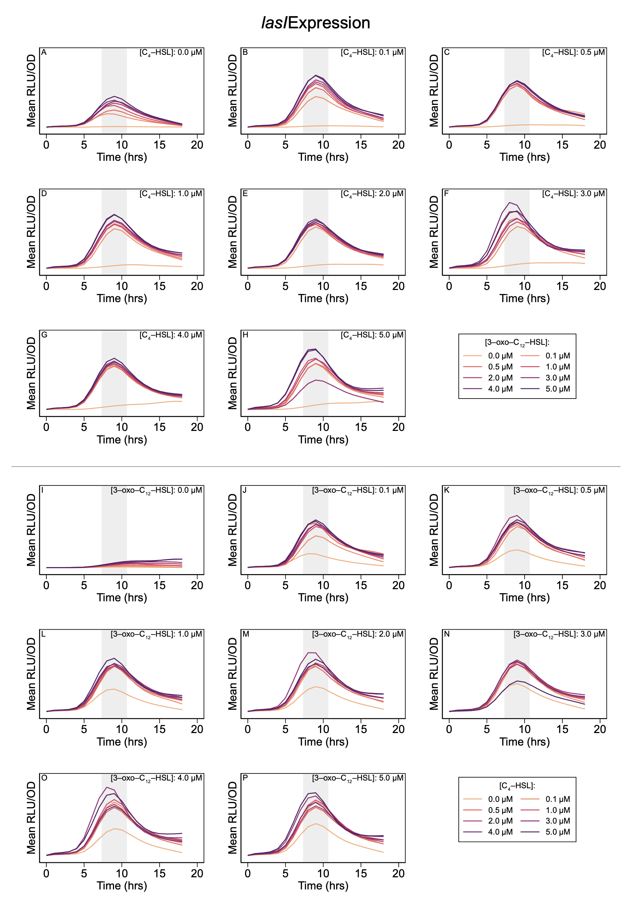

**Figure S.1. Expression level of lasI over time course of experiment.** Shaded regions highlight peak expression and indicate two-hour period used in analysis.

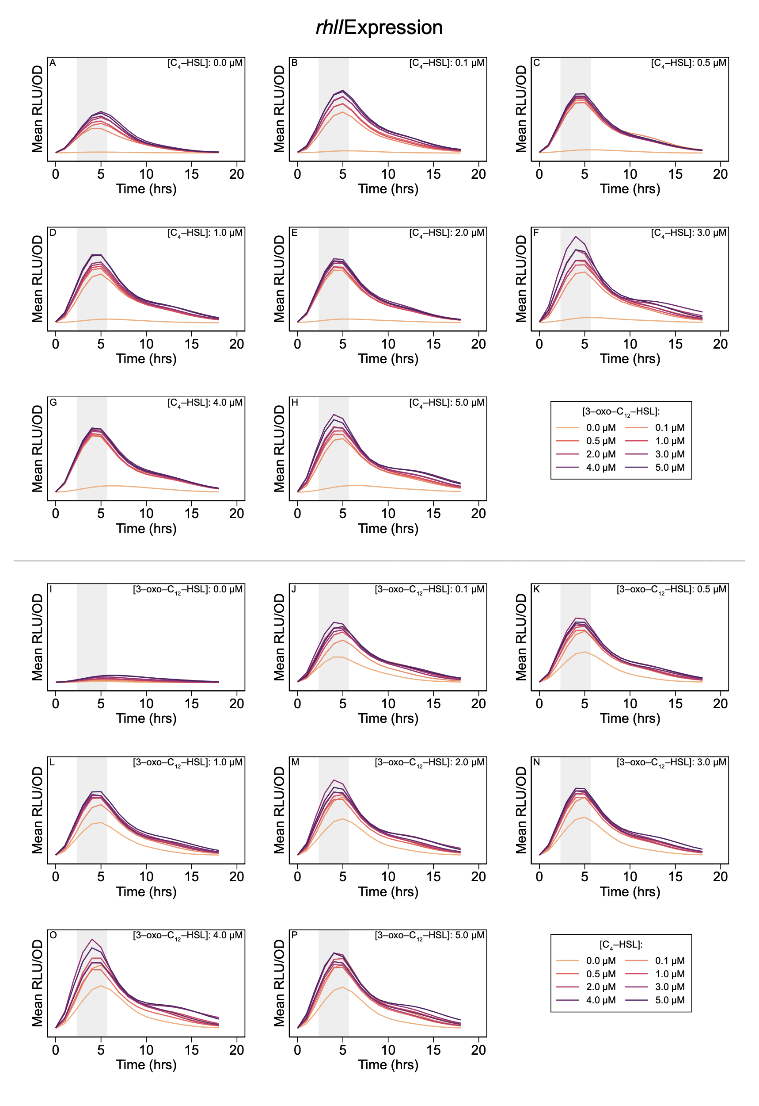

**Figure S.2. Expression level of rhlI over time course of experiment.** Shaded regions highlight peak expression and indicate two-hour period used in analysis.

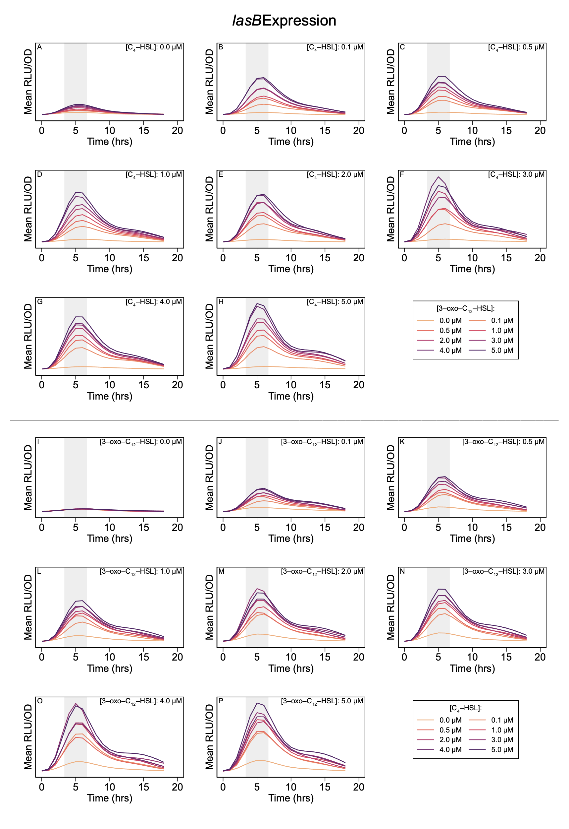

**Figure S.3. Expression level of lasB over time course of experiment.** Shaded regions highlight peak expression and indicate two-hour period used in analysis.

### Multi-Signal Models

Figure 7 in the main text summarizes the predictions of the multi-signal models for *lasI* and *rhlI* expression. The following figures provide a more detailed comparison of the model predictions for all three genes.

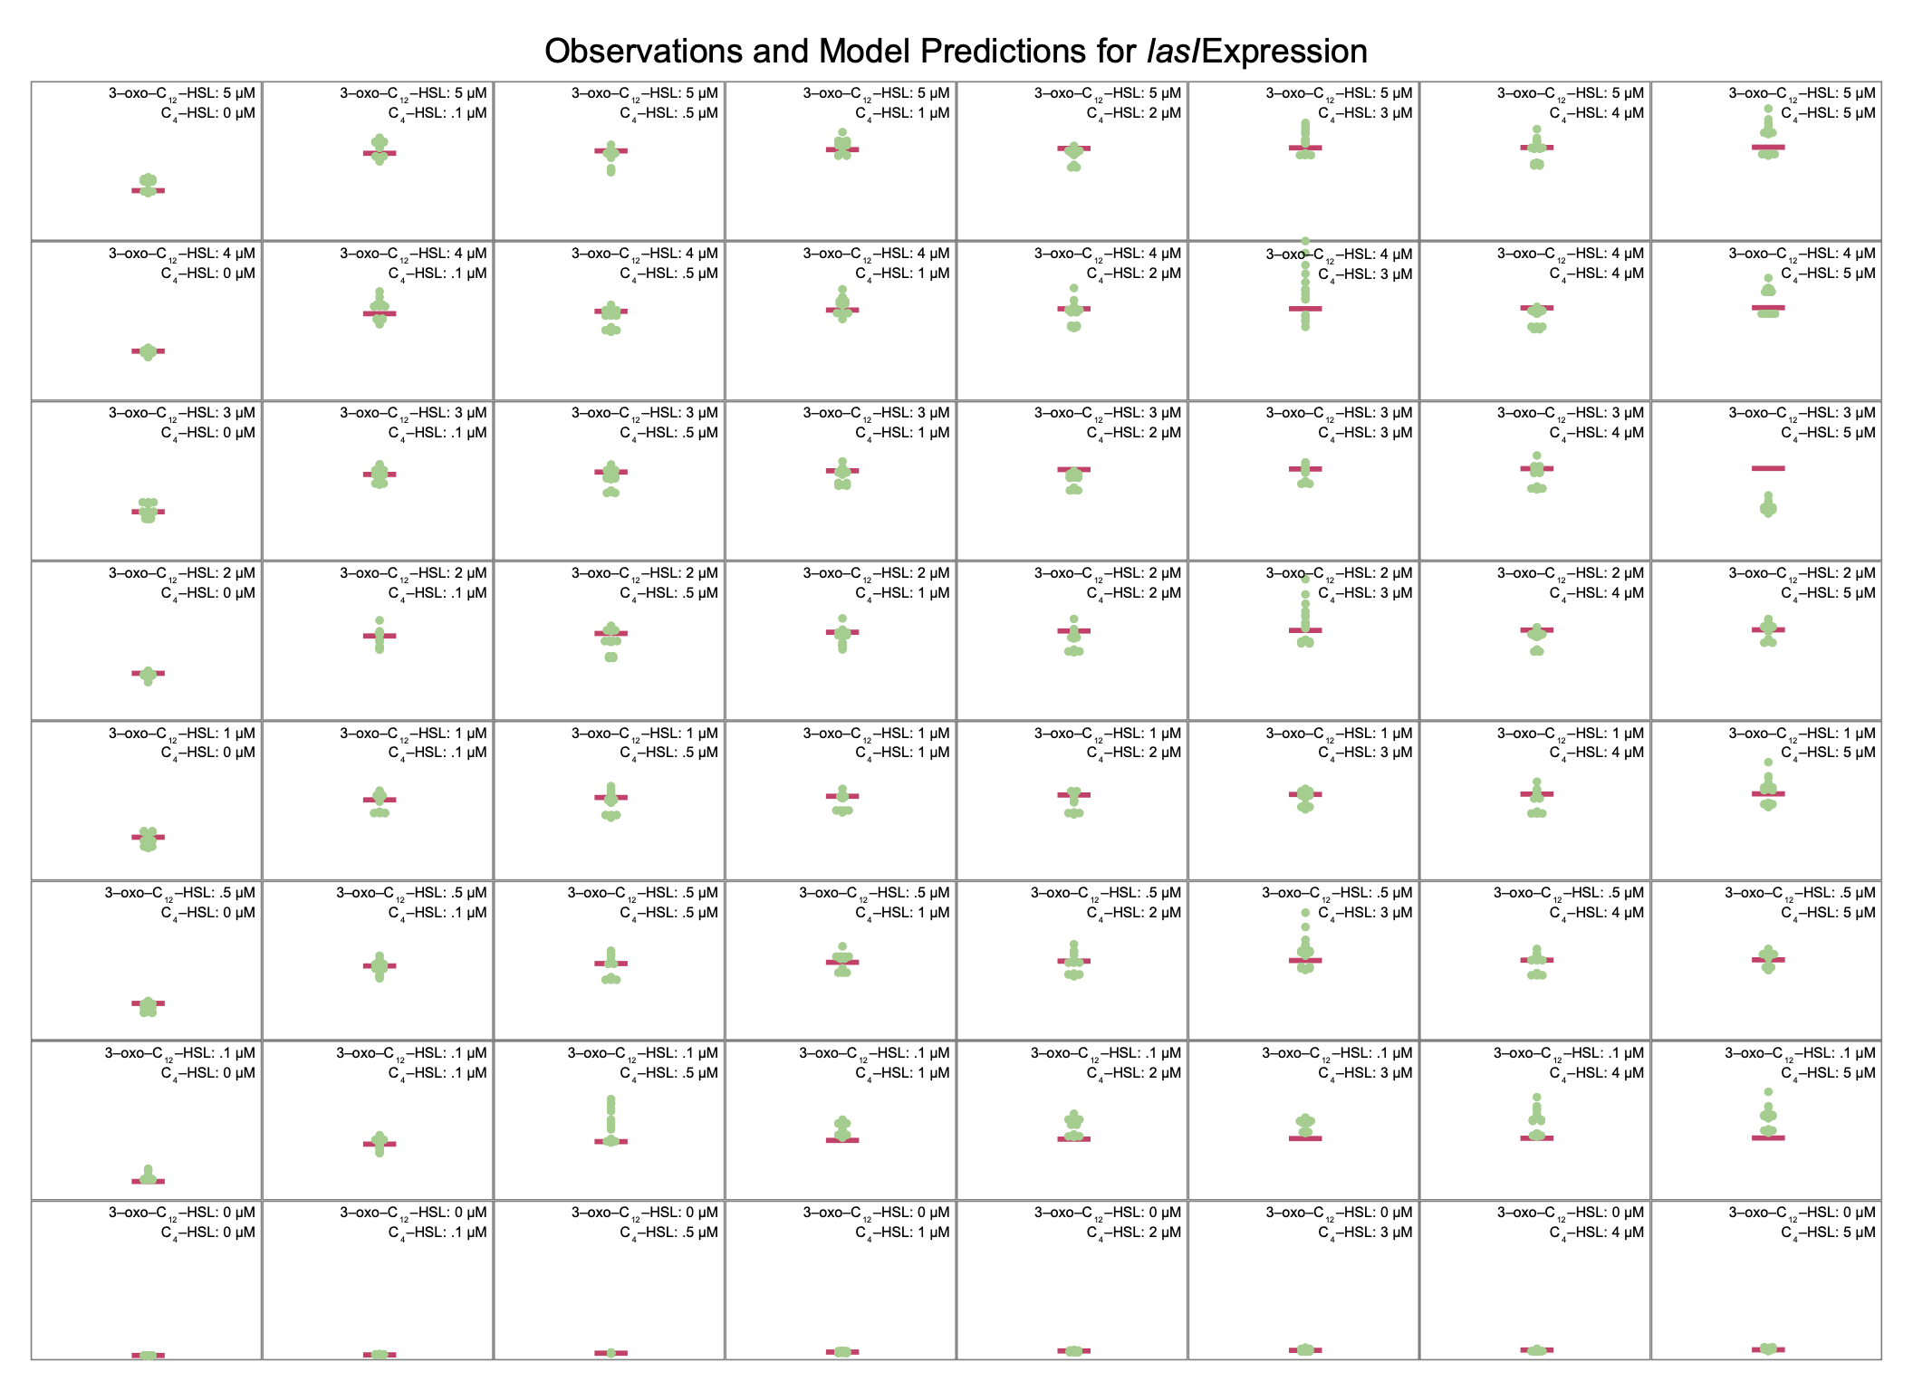

**Figure S.4. Multi-signal model for lasI expression.** Panels compare model predictions to observations for all combinations of signal concentrations. Horizontal bars indicate model predictions, while plotted points show observed values.

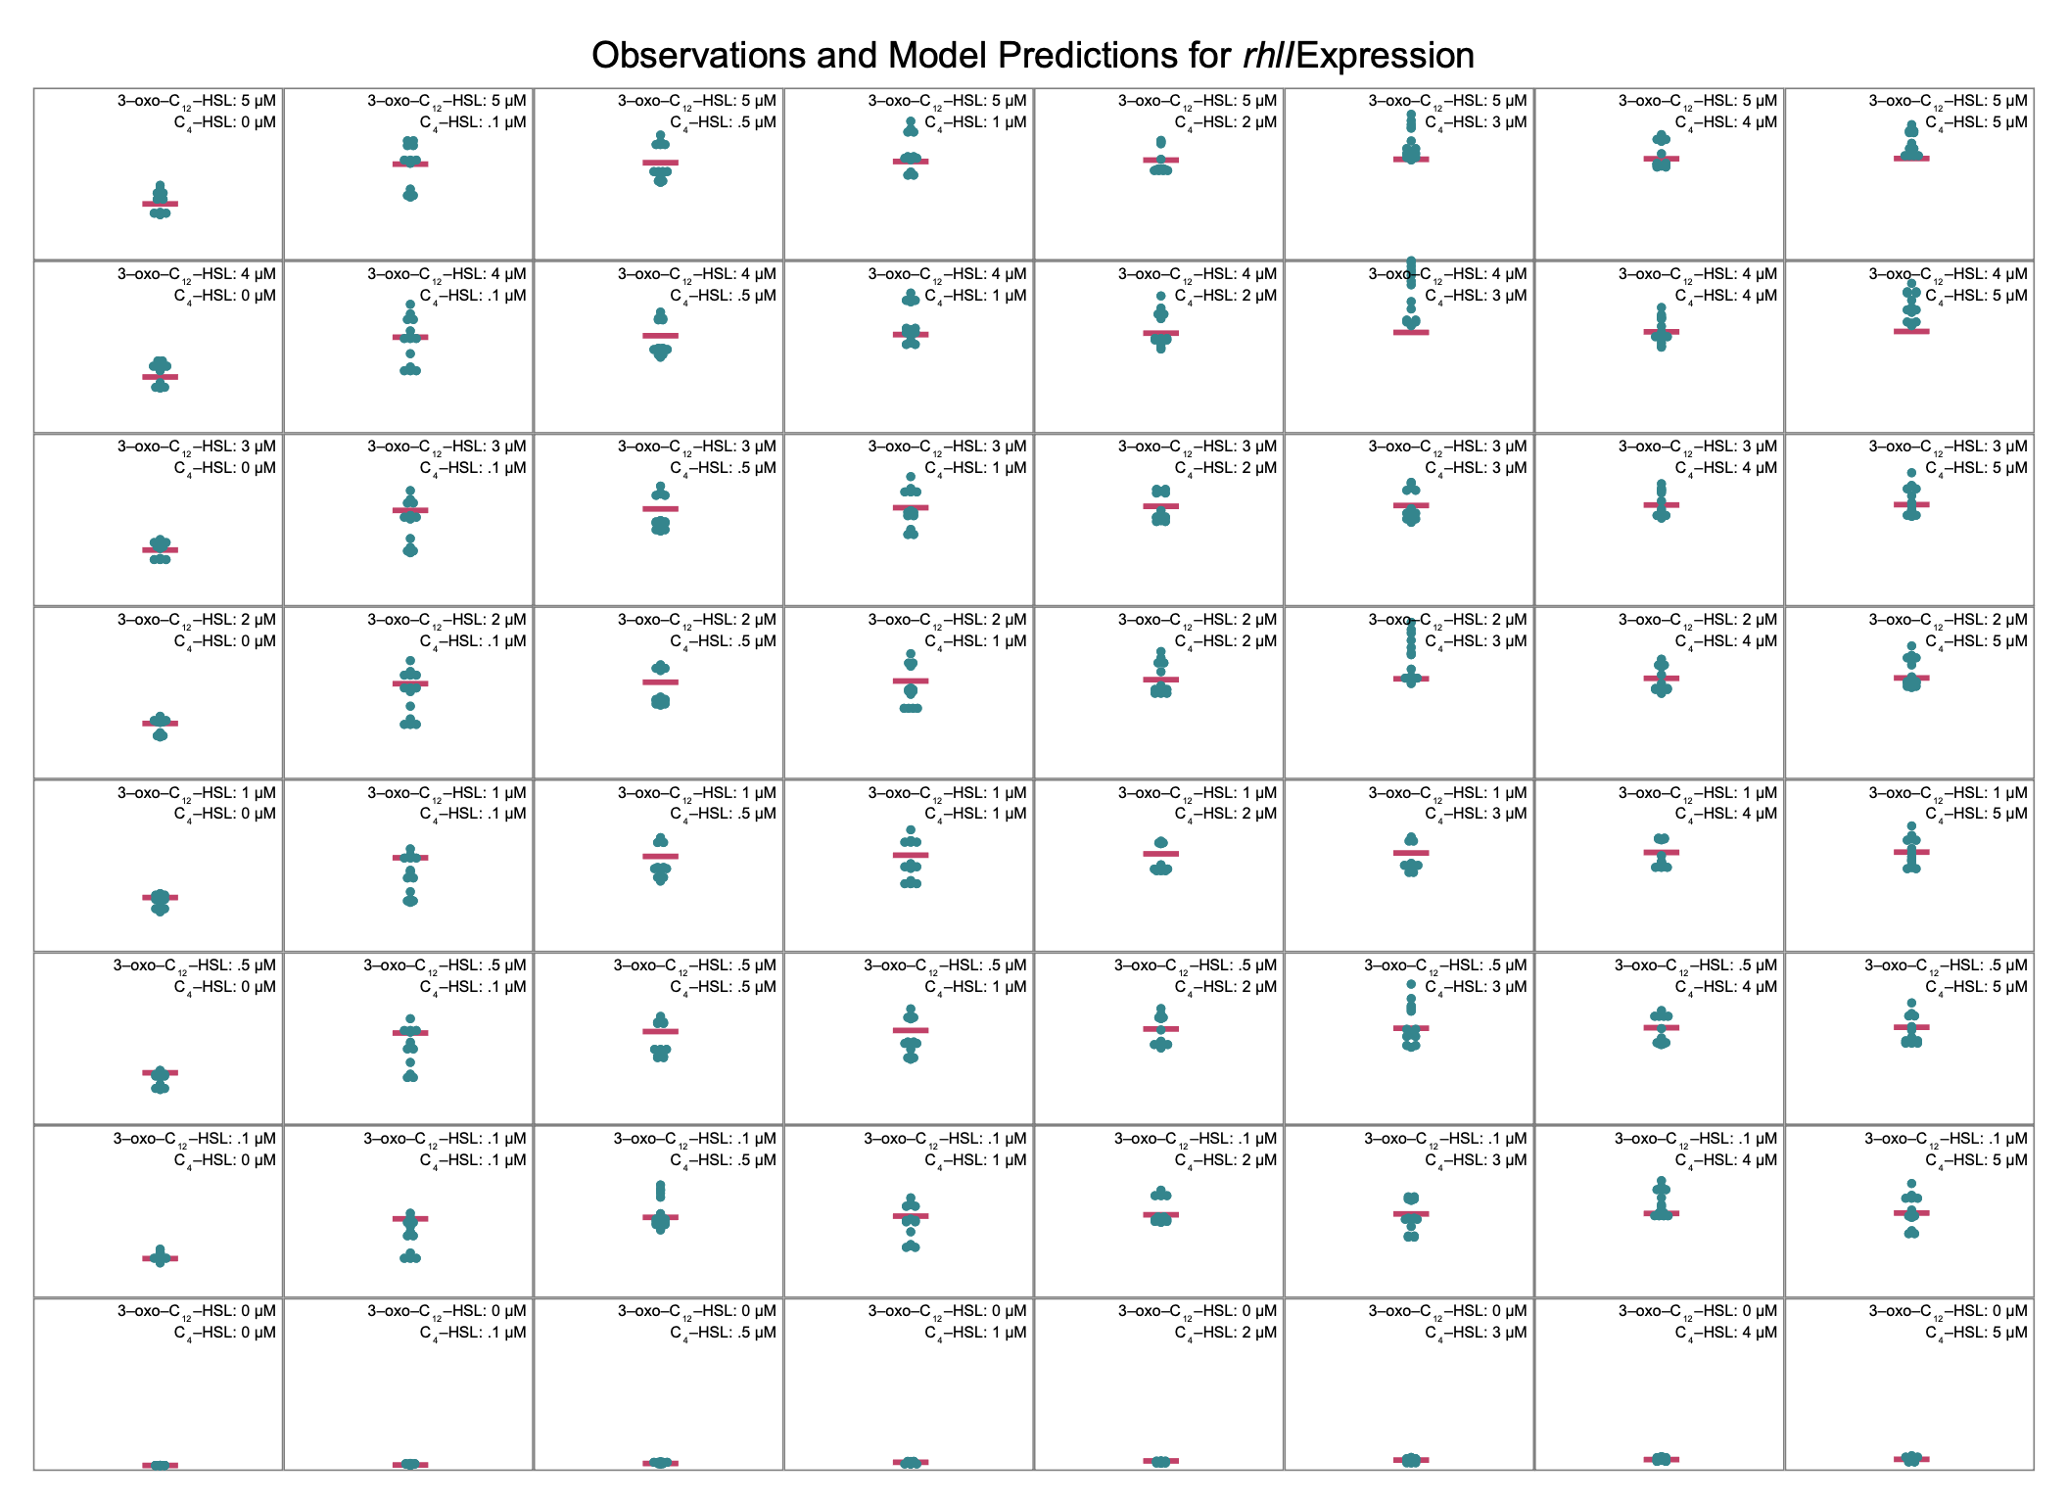

**Figure S.5. Multi-signal model for rhlI expression.** Panels compare model predictions to observations for all combinations of signal concentrations. Horizontal bars indicate model predictions, while plotted points show observed values.

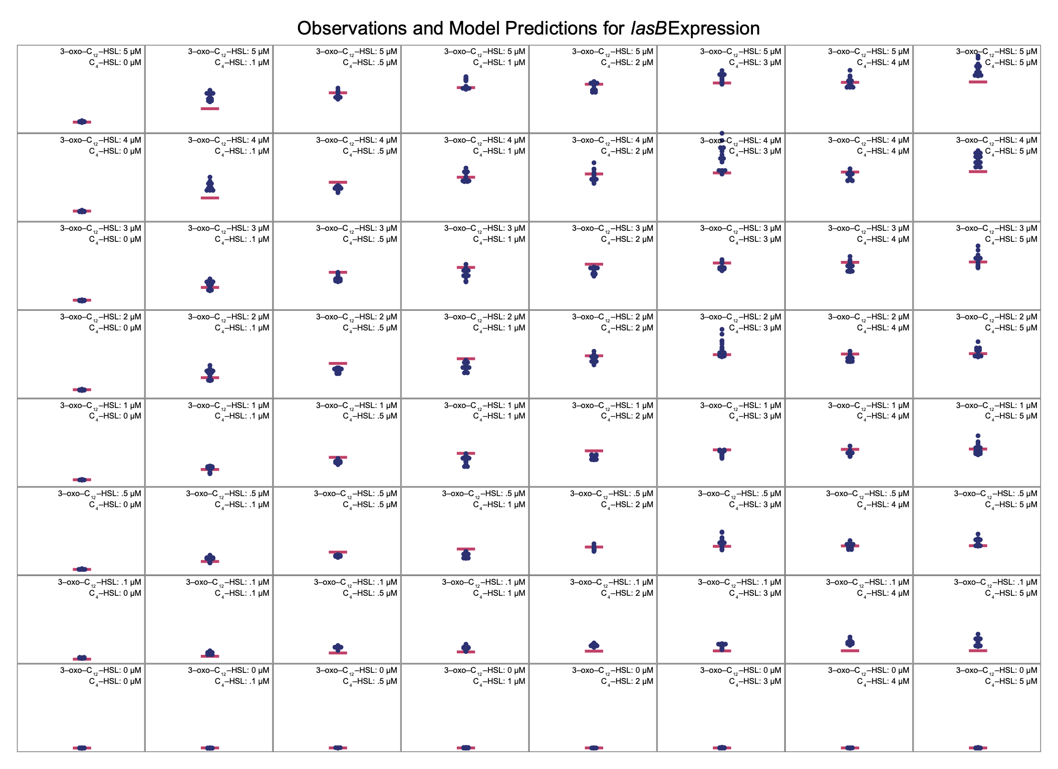

**Figure S.6. Multi-signal model for lasB expression.** Panels compare model predictions to observations for all combinations of signal concentrations. Horizontal bars indicate model predictions, while plotted points show observed values.

### Signal Dynamics

We analyze signal dynamics using the model from the main text where the per-capita single production rater is assumed to be proportional to the synthase expression level, $E_{i}\left(S\right)$. The proportionality constant is $c_{i}$.

$$\frac{dS_{i}}{dt} = c_{i}E_{i}\left(S\right)⋅N - δ_{i}⋅S_{i} - m⋅S_{i}$$

We consider the equilibrium signal concentration (where $dS/dt=0$) and normalize to the decay rate of C4‑HSL (). When there is no mass transfer ($m=0$), these simplifications result in an equation for C4‑HSL,

which can be solved for $c_{2}/δ_{2}$ in terms of *rhlI* expression $E_{2}\left(S\right)$, density , and C4‑HSL concentration $S_{2}$. The corresponding equation for 3‑oxo‑C12‑HSL includes an additional factor $δ_{1}/δ_{2}$ which, from (Cornforth et al. 2014), we take to be approximately 1.7.

$$0 = \frac{c_{1}}{δ_{2}}E_{1}\left(S\right)⋅N - \frac{δ_{1}}{δ_{2}}S_{1}$$

Data from (Rattray et al. 2022) includes measurements of equilibrium signal concentrations at multiple population densities. We combine those measurements of $N$ and $S_{i}$ with our model’s estimate of synthase expression level $E_{i}\left(S\right)$ and use non-linear least squares to estimate the proportionality constants.

| Signal *i* | Proportionality Constant |
| --- | --- |
| **3‑oxo‑C12‑HSL** | 1.3 nM/RLU |
| **C4‑HSL** | 2.5 nM/RLU |

**Table S.3.** Estimated proportionality constants that relate synthase expression levels to per-capita signal production rates. Final column shows adjusted R2 of non-linear least squares estimate.

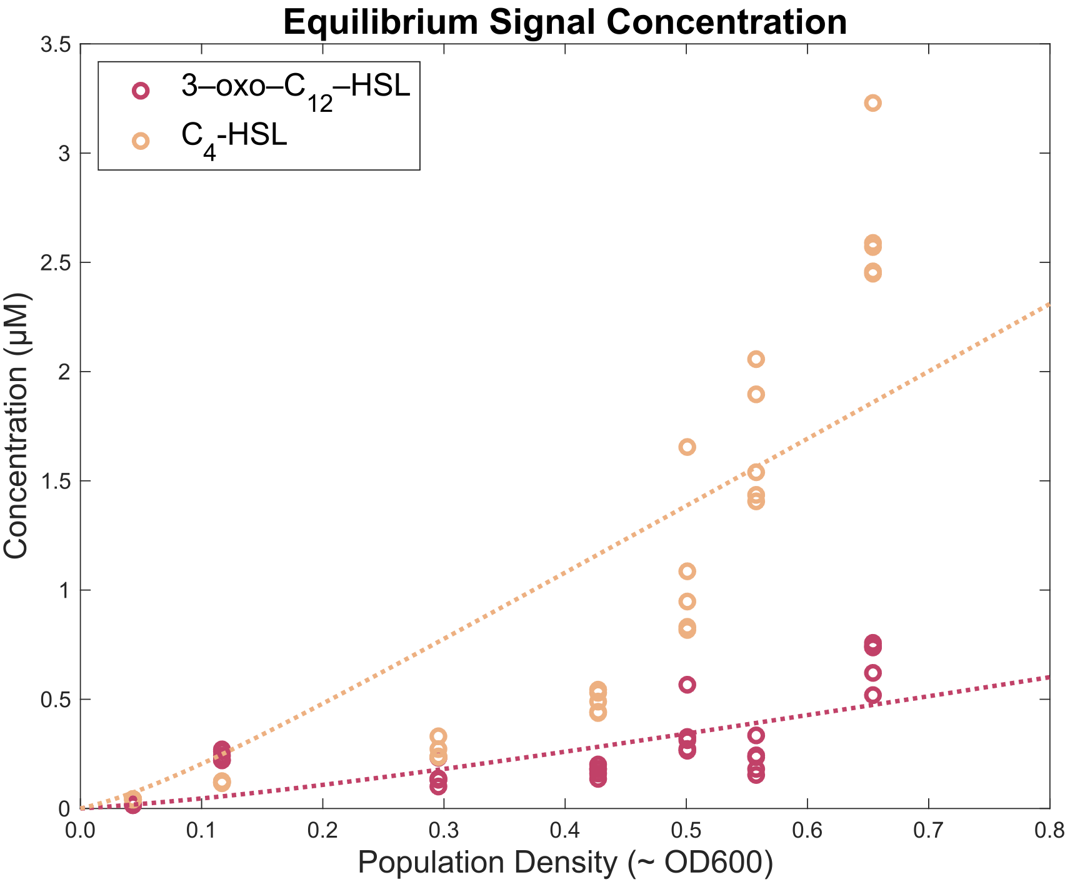

**Figure S.7. Equilibrium signal concentration predicted using proportionality constants.** Individual data points show experimental observations and dashed lines indicate model predictions.

### Normalizing Alternate QS Architectures

The main text analyzes hypothetical, alternative architectures by eliminating the influence of specific signals on specific genes. For example, the hierarchical architecture nullifies the influence of C4‑HSL on *lasI* without modifying the effect of 3‑oxo‑C12‑HSL on *lasI.* This change necessarily reduces the maximum expression level of *lasI,* and that reduction partially explains the different *lasB* response in a hierarchical architecture. Reducing maximum *lasI* expression alone, however, does not explain all of the differences in the *lasB* response. To expose those additional differences, we make additional adjustments to the model. In particular, we increase the expression of *lasI* due to 3‑oxo‑C12‑HSL to precisely compensate for the loss of expression due to C4‑HSL. Table S.4 shows the full set of adjustments required to normalize the maximum synthase expression levels across all architectures.

| Gene | Signal | Parameter | Derivation | Reciprocal Architecture | Hierarchical Architecture | Independent Architecture |
| --- | --- | --- | --- | --- | --- | --- |
| *lasI* | 3‑oxo‑C12‑HSL | Max fold-change | (*ɑ*1,1 + *ɑ*1,0) / *ɑ*1,0 | 38 × | 73 × | 73 × |
|  | C4‑HSL | Max fold-change | (*ɑ*1,2 + *ɑ*1,0) / *ɑ*1,0 | 6.4 × | 1 × | 1 × |
|  | Combined | Max fold-change | (*ɑ*1,1,2 + *ɑ*1,0) / *ɑ*1,0 | 30 × | 1 × | 1 × |
| *rhlI* | 3‑oxo‑C12‑HSL | Max fold-change | (*ɑ*2,1 + *ɑ*2,0) / *ɑ*2,0 | 35 × | 35 × | 1 × |
|  | C4‑HSL | Max fold-change | (*ɑ*2,2 + *ɑ*2,0) / *ɑ*2,0 | 6.4 × | 6.4 × | 66 × |
|  | Combined | Max fold-change | (*ɑ*2,1,2 + *ɑ*1,0) / *ɑ*1,0 | 27 × | 27 × | 1 × |

**Table S.4. Models of hierarchical and independent architectures can be normalized to ensure that maximum synthase expression is the same for all architectures.** Parameters are the same as those in the main text but with increased values where appropriate.

The result of these adjustments, shown in Figure 8 shows the same qualitative differences as the unnormalized models in the main text. The reciprocal architecture remains the most sensitive to changes in population density and the most robust to signal loss from mass transfer.

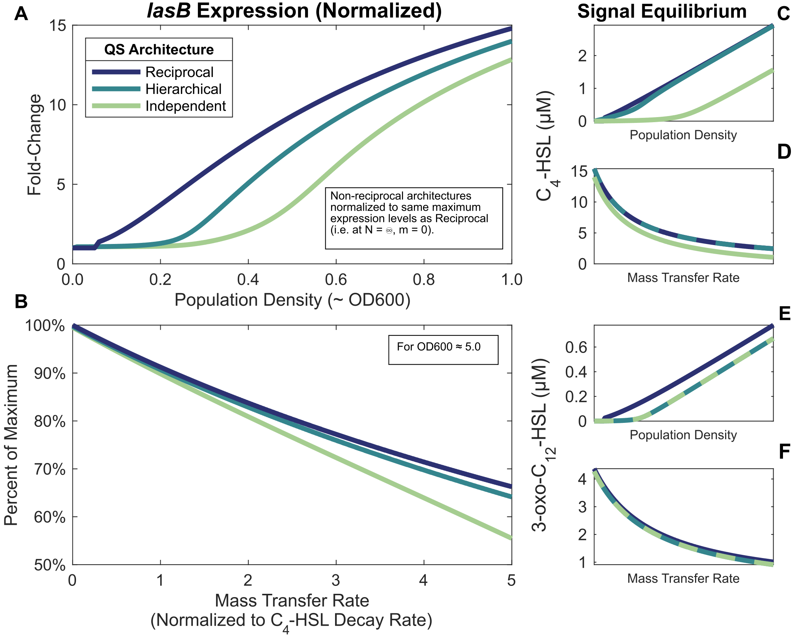

**Figure 8. The reciprocal QS architecture is more sensitive to population density and more robust to environmental interference.** Plots are the same as those in the corresponding figure in the main text, but show the normalized models.

## References

Cornforth, DM, R Popat, L McNally, J Gurney, TC Scott-Phillips, A Ivens, SP Diggle, and SP Brown. 2014. “Combinatorial Quorum Sensing Allows Bacteria to Resolve Their Social and Physical Environment.” *Proc Natl Acad Sci U S A* 111 (11): 4280–84.

De Sordi, L, and FA Mühlschlegel. 2009. “Quorum Sensing and Fungal-Bacterial Interactions in *Candida Albicans:* A Communicative Network Regulating Microbial Coexistence and Virulence.” *FEMS Yeast Res* 9 (7): 990–99.

Donabedian, H. 2003. “Quorum Sensing and Its Relevance to Infectious Diseases.” *J Infect* 46 (4): 207–14.

García-Reyes, S, G Soberón-Chávez, and M Cocotl-Yanez. 2020. “The Third Quorum-Sensing System of *Pseudomonas Aeruginosa:* Pseudomonas Quinolone Signal and the Enigmatic PqsE Protein.” *J Med Microbiol* 69 (1): 25–34.

Heurlier, K, V Dénervaud, and D Haas. 2006. “Impact of Quorum Sensing on Fitness of *Pseudomonas Aeruginosa.*” *Int J Med Microbiol* 296 (2-3): 93–102.

Jakobsen, TH, T Bjarnsholt, PØ Jensen, M Givskov, and N Høiby. 2013. “Targeting Quorum Sensing in *Pseudomonas Aeruginosa* Biofilms: Current and Emerging Inhibitors.” *Future Microbiol* 8 (7): 901–21.

Juhas, M, L Eberl, and B Tümmler. 2005. “Quorum Sensing: The Power of Cooperation in the World of *Pseudomonas.*” *Environ Microbiol* 7 (4): 459–71.

Le Berre, R, K Faure, S Nguyen, M Pierre, F Ader, and B Guery. 2006. “[Quorum Sensing: A New Clinical Target for *Pseudomonas Aeruginosa*?].” *Med Mal Infect* 36 (7): 349–57.

Papaioannou, E, PD Utari, and WJ Quax. 2013. “Choosing an Appropriate Infection Model to Study Quorum Sensing Inhibition in *Pseudomonas* Infections.” *Int J Mol Sci* 14 (9): 19309–40.

Proctor, CR, PA McCarron, and NG Ternan. 2020. “Furanone Quorum-Sensing Inhibitors with Potential as Novel Therapeutics Against *Pseudomonas Aeruginosa.*” *J Med Microbiol* 69 (2): 195–206.

Rattray, JB, SA Thomas, Y Wang, E Molotkova, J Gurney, JJ Varga, and SP Brown. 2022. “Bacterial Quorum Sensing Allows Graded and Bimodal Cellular Responses to Variations in Population Density.” *mBio* 13 (3): e0074522.

Reuter, K, A Steinbach, and V Helms. 2016. “Interfering with Bacterial Quorum Sensing.” *Perspect Medicin Chem* 8: 1–15.

Roy, V, BL Adams, and WE Bentley. 2011. “Developing Next Generation Antimicrobials by Intercepting AI-2 Mediated Quorum Sensing.” *Enzyme Microb Technol* 49 (2): 113–23.

Rutherford, ST, and BL Bassler. 2012. “Bacterial Quorum Sensing: Its Role in Virulence and Possibilities for Its Control.” *Cold Spring Harb Perspect Med* 2 (11): a012427.

Schuster, M, DJ Sexton, SP Diggle, and EP Greenberg. 2013. “Acyl-Homoserine Lactone Quorum Sensing: From Evolution to Application.” *Annu Rev Microbiol* 67: 43–63.

Soukarieh, F, P Williams, MJ Stocks, and M Cámara. 2018. “*Pseudomonas Aeruginosa* Quorum Sensing Systems as Drug Discovery Targets: Current Position and Future Perspectives.” *J Med Chem* 61 (23): 10385–402.

Tateda, K. 2005. “[*Pseudomonas Aeruginosa* Infection and the Quorum-Sensing Mechanism].” *Nihon Naika Gakkai Zasshi* 94 (5): 999–1004.

Welsh, MA, and HE Blackwell. 2016. “Chemical Probes of Quorum Sensing: From Compound Development to Biological Discovery.” *FEMS Microbiol Rev* 40 (5): 774–94.

Williams, P, K Winzer, WC Chan, and M Cámara. 2007. “Look Who’s Talking: Communication and Quorum Sensing in the Bacterial World.” *Philos Trans R Soc Lond B Biol Sci* 362 (1483): 1119–34.

Winzer, K, and P Williams. 2001. “Quorum Sensing and the Regulation of Virulence Gene Expression in Pathogenic Bacteria.” *Int J Med Microbiol* 291 (2): 131–43.

Yong, YC, and JJ Zhong. 2013. “Impacts of Quorum Sensing on Microbial Metabolism and Human Health.” *Adv Biochem Eng Biotechnol* 131: 25–61.